USING THE DATABIZ EOLAS APP

Section 1 - Dashboard

Once logged in the dashboard is displayed.
The icons numbered will show

to
information relating to all the children the logged in user has access to and are explained in Section 2 – Dashboard icons.

The avatar for each child the user has access to will bring the user to the screen below and allow them to see all the information on the system specific to that child. This screen is explained in Section 3 – Individual
Pupil icons
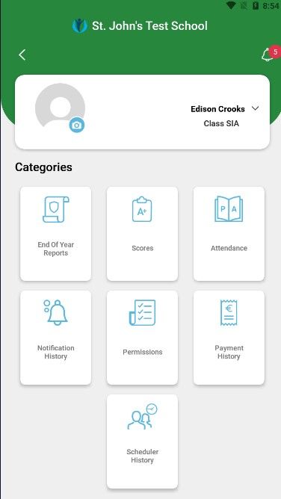

Section 2 – Dashboard icons
The icons on this screen access the following:
Notifications sent for all children, with the number of unread notifications highlighted in red.

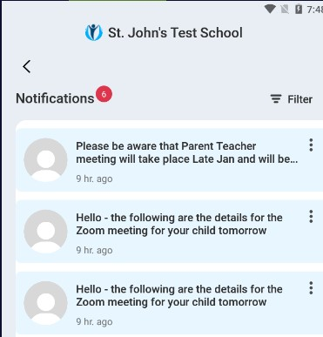
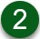
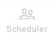
Upcoming Parent/Teacher meetings and allows the parent to book a time for the meeting:

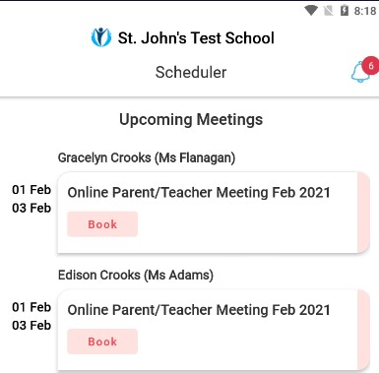
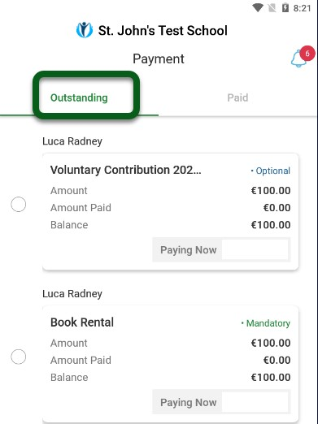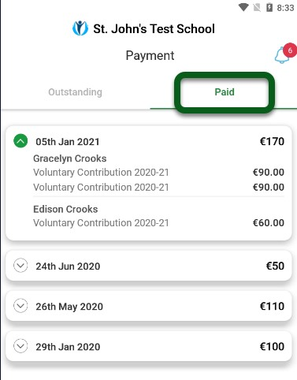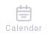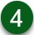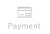

The School
Y
ear Calendar.

A
list of Outstanding
C
harges

(
Outstanding

tab
)

and
pay
men
ts that have
been made (
Paid

tab
)

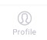
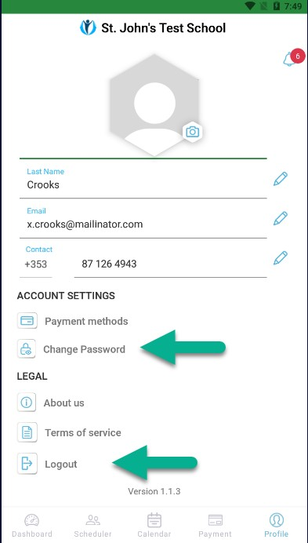
The user’s profile and allows them to Change Password and Logout of the app.

Section 3 – Individual Pupil icons

The icons on this screen access the following:
This back arrow is always available to bring you back one screen.
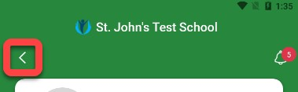

 | Allows the user to upload a picture to replace the current avatar.
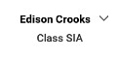 | Allows the user to switch to other children without going back to the dashboard.
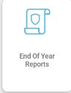 | Displays a list of End of Year reports that are available to download for the child.
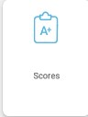 | Displays a list of Standardised Test scores that have been recorded for the child.
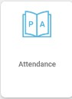 | Summarises the child’s attendance and list their absences, the Unexplained tab allows the user to submit a Reason why the child was absent on a particular day  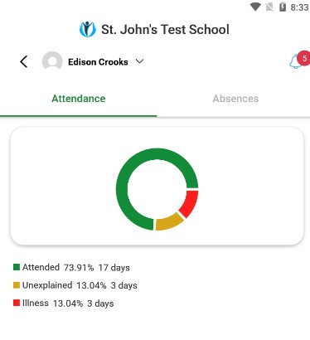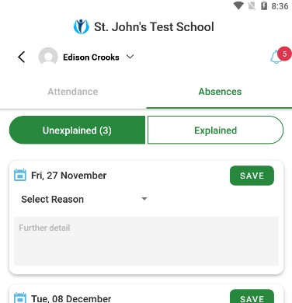
 | 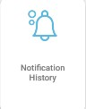 |  | Displays a list of notifications sent regarding this child and the Filter option can be used to see specific types of Notifications  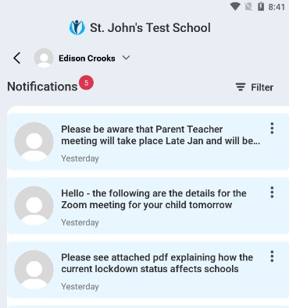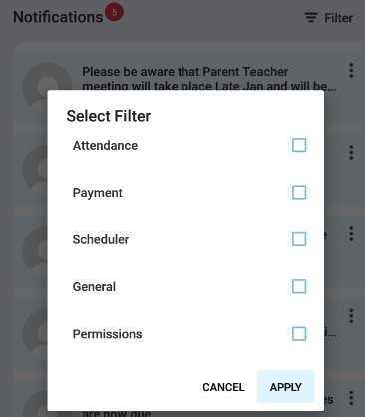
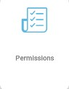 |  |  | Displays a list of Permissions that the school has regarding the child and these can be switched On/Off as appropriate.  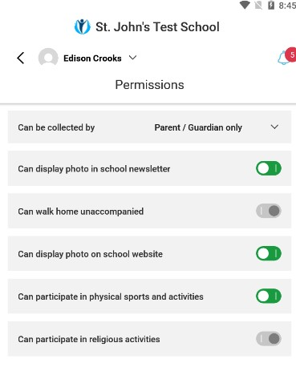
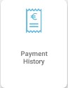 |  |  | Displays a list of Payments that have been made for this child.  - Use the By Charge or By Date options to see specific charges or payments  - Use the Outstanding Payments button to make a payment  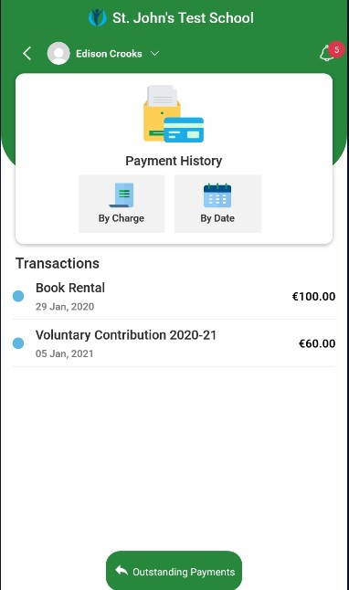

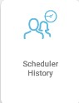 | Displays a list of Meetings that have been scheduled for this child.  